Introduction of Siemens Industrial Automation Products Ltd., Chengdu(SEWC):
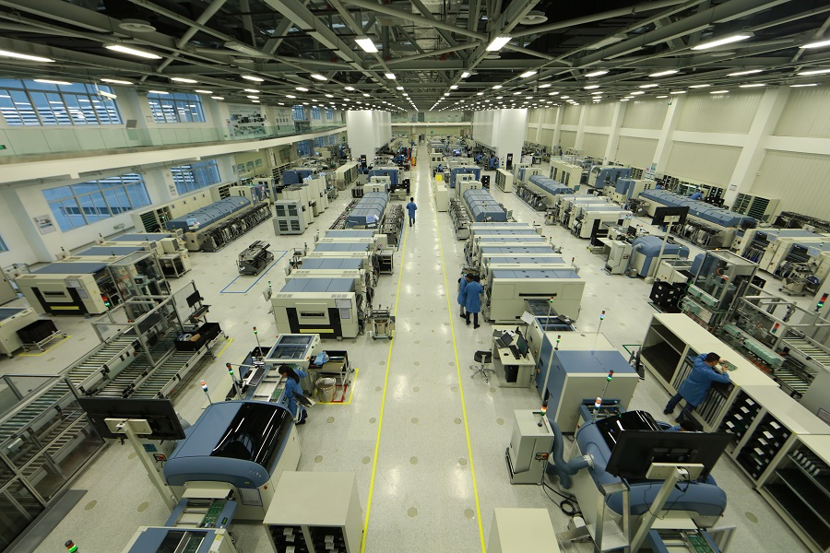
SEWC has been built and put into production in west high-tech zone of Chengdu in the first half of 2013.
SEWC has became the first digital factory of Siemens China in R&D, manufacturing, quality control and logistic system by utilizing Siemens digital software suite and SIMATIC applications, etc.
SEWC develops and produces of SIMATIC industrial automation products (includingPLC-Programmable Logic Controller, HMI-Human Machine Interfaces, IPC-Industrial PC) to supply China and global industrial market, which are widely used in automotive, machinery manufacturing, food and beverage, pharmaceutical, glass,cement, metallurgy, electric power , petrochemical industry, metro transportation and other fields.
SEWC consistently provides high quality products and on time delivery commitment through digitalization solution and intelligent
manufacturing, in order to fulfill the customer value expectation and satisfaction improvement.
西门子工业自动化产品(成都)有限公司(SEWC)介绍:
西门子工业自动化产品(成都)有限公司(SEWC)座落于成都市高新西区, 于2013年上半年建成投产。
SEWC自成立以来，通过西门子数字化软件套件和SIMATIC等产品及应用，全面实现了研发，制造、质量管理和物流系统的数字化，成为西门子在中国的首家数字化工厂。
SEWC主要负责研发和生产SIMATIC工业自动化系统系列产品(包括PLC-可编程逻辑控制器，HMI-人机交互界面，IPC-工业电脑)，以供应中国及全球工业市场；该系列产品被广泛应用于汽车，机械制造，食品饮料，制药, 玻璃, 水泥，冶金，电力，石油化工，地铁轨道交通等领域。
SEWC持续致力于通过数字化解决方案和智能制造为客户提供高质量和准时交付的产品，从而不断提高客户满意度并实现客户增值！
General Information
Chengdu is the capital of Sichuan province in Southwest China and is one of the most important economic, transportation and communication centers in Western China. It is one of China’s largest cities and its economy has been keeping a two-digitgrowth rate for 14 years. What is more, ChengDu has profound cultural and historic significance with great charm and a welcoming atmosphere.
